PRINTING DIGITS

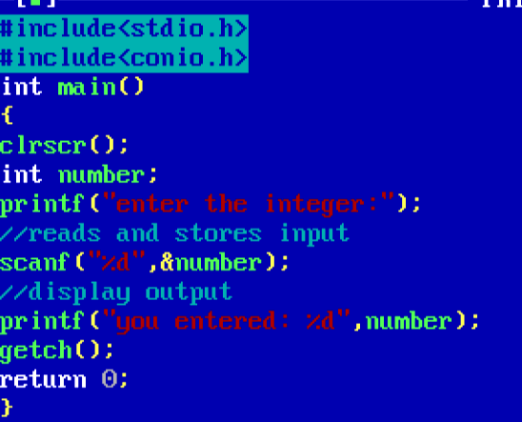

OUTPUT

